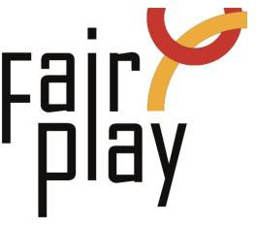

SUBMISSION OF CANDIDACY QUESTIONNAIRE FOR C.I.F.P. AWARDS
NOMINATIONS FOR THE YEAR 2025

Jean Borotra World Fair Play Trophy - 2025
Jean Borotra World Fair Play Trophy to a person for his/her remarkable general attitude showed all along his/her sport career, for an outstanding and constant spirit of fair play, for observing the unwritten rule of sport not to take advantage of an opponent's bad luck.

1. Details of the person or organization proposed for the nomination:
Ms./Mr./organization *
Ms.

Mr.

Organization

Name: *
Country: *
E-mail: *

Profession or current occupation: *

2. Summary of the sport career and sport performances (max. 50 words): *

3. Summary of other functions in sport (trainer, sport official): *

4. Description connection with aspects of fair play: *

5. Source (preferably in English): *

6. Details of the person or organization submitting this nomination:

Name: *

E-mail: *

Please attach all available supporting evidence (photos, press clippings, reports etc.) justifying this nomination as well as a PHOTO

